When user presses Confirm in Reminder Details Page it leads a wrong page; it leads to the Reminders Page instead of the Reminders Details Page. Make it so that after the user presses confirm it leads to the Reminders Details Page.

Akilan: Will implemented it during server implementation

Start Work Page:

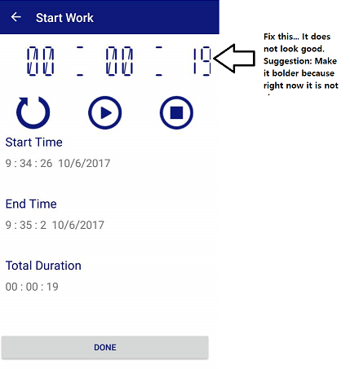

Akilan: Have changed it.

**WORK ON THIS:** For the Side Menu(After pressing the hamburger button), I don’t like the orange highlighter. So, make the highlighter look exactly like this: (I only want the highlighting to change, nothing else)

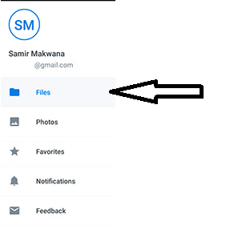

Side Menu #2:

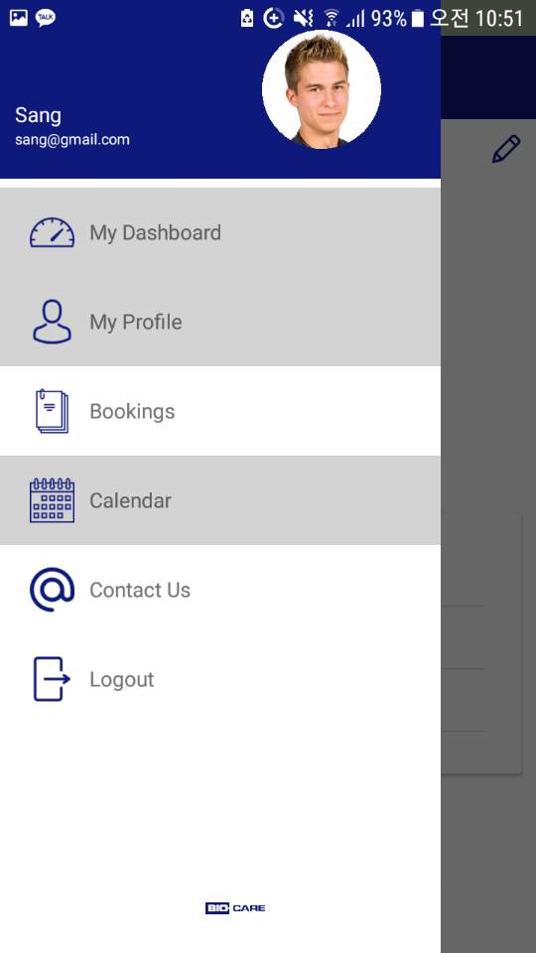

There seems to be some error in the menu bar right now. It highlights multiple slides even though I am only on one of the page. Also, make the font blue (same color as the icons) ( I liked the color before)

My Profile Page:

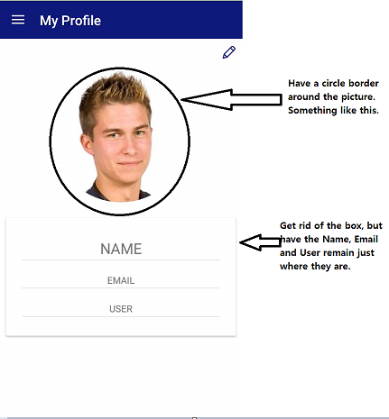

Error #2:

Also, for all the four pages(Completed Bookings Page, Scheduled Bookings Page, Reminders Page, Notifications Page), when the user presses on the information button( that leads to the details page) twice quickly, it opens the details page twice.